Week 2 Internship Task Summary

Topic: Data Structures and Functions in Python

1. Introduction
In Week 2 of the Python internship, I studied important Python concepts such as data structures and functions. These concepts are essential for organizing, processing, and transforming data efficiently.
During this task, I also completed a client project that focused on data cleaning, where I wrote a Python script to remove duplicate records and filter useful data from a dataset.

2. Concepts Learned

Python Data Structures
Python provides several data structures that help store and manage data efficiently.
- Lists – Ordered collection that can store multiple items
- Tuples – Similar to lists but immutable
- Dictionaries – Store data as key-value pairs
- Sets – Store unique values and automatically remove duplicates
These structures are widely used in data processing tasks.

Functions
Functions are reusable blocks of code used to perform a specific task. They help in writing clean, organized, and reusable code.
Example:
def calculate_square(number):
return number * number
Functions were used in this task to perform operations such as data cleaning and transformation.

Lambda Functions
Lambda functions are small anonymous functions used for simple calculations.
Example:
square = lambda x: x**2
They are useful for short and quick operations in data processing.

List Comprehension
List comprehension is a concise way of creating lists in Python.
Example:
squares = [x**2 for x in range(10)]
It helps make the code shorter and more efficient.

3. Hands-On Practice
During this task, I practiced working with Python data structures and wrote functions to perform data transformation operations, such as calculating the sum of squares and filtering data based on conditions.
These exercises helped me understand how Python can efficiently process and manipulate datasets.

4. Client Project – Data Cleaning Script
For the client project, I created a Python script for data cleaning. The script reads a dataset containing student scores and performs several data cleaning operations.

Operations performed by the script:
- Read dataset from a CSV file
- Remove duplicate records
- Filter students based on score conditions
- Perform data transformations such as calculating squared scores
The script processes the dataset and displays the cleaned results in the terminal.

5. Output
After executing the Python script, the dataset was successfully processed. Duplicate entries were removed and only relevant records were displayed based on the filtering conditions.
The output confirmed that the data cleaning operations were successfully performed.
screenshots
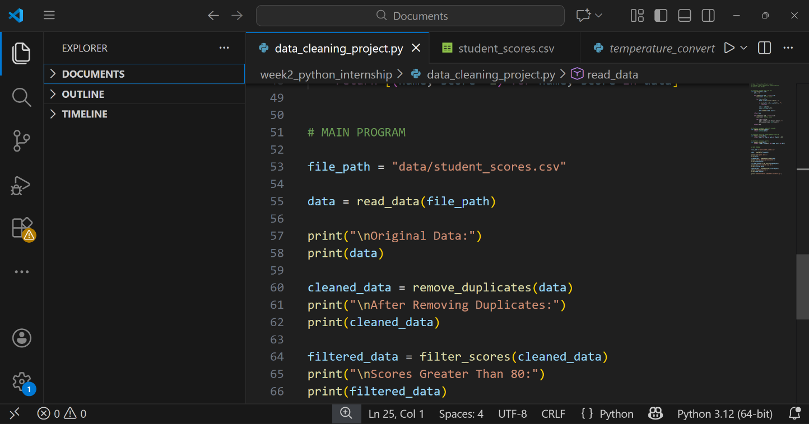

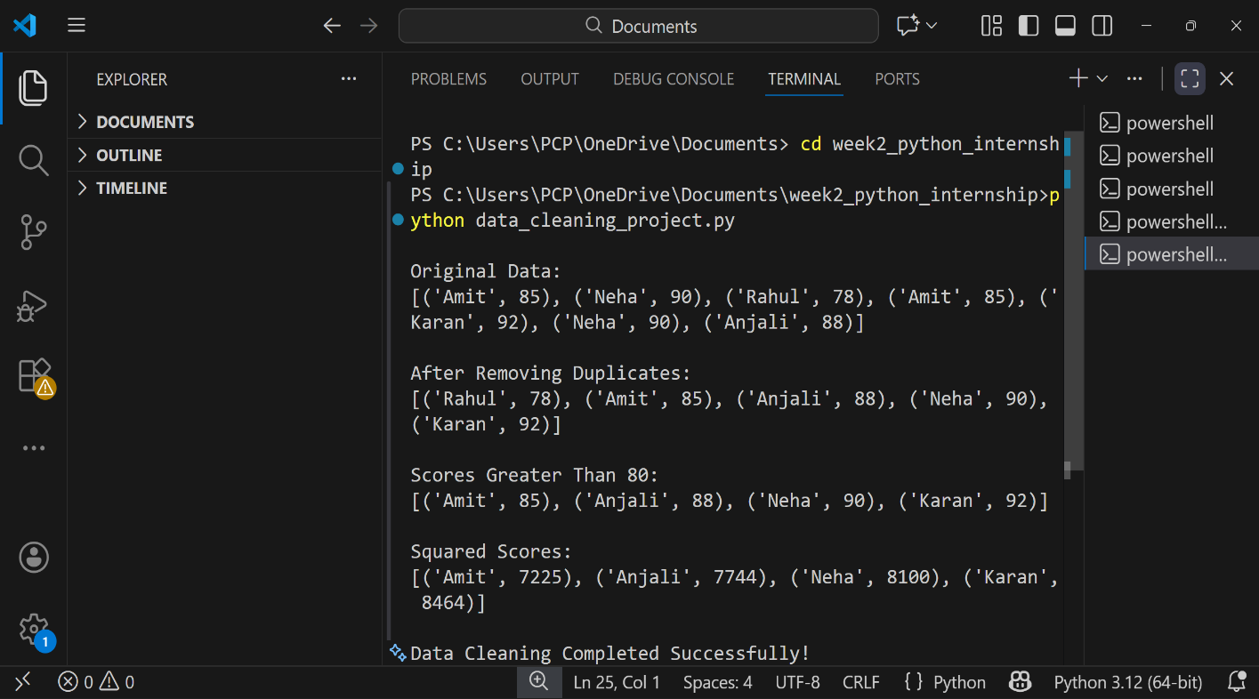

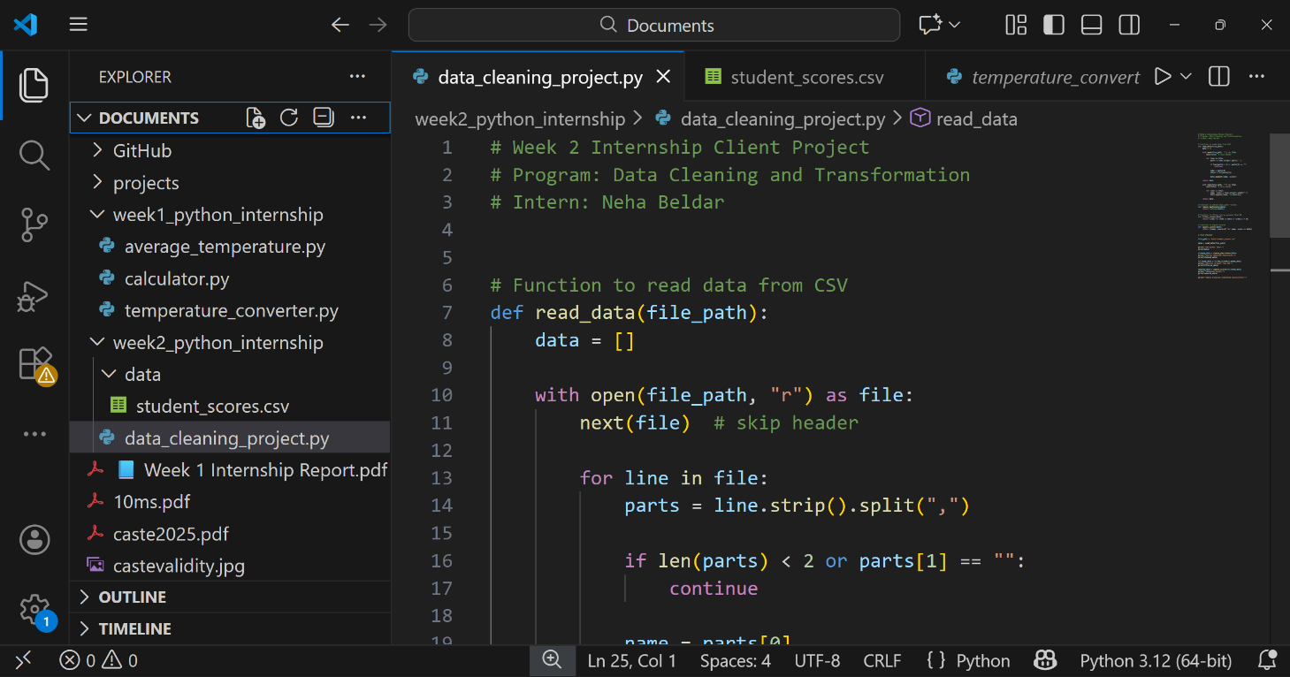

6. Conclusion
This task helped me understand the importance of data structures and functions in Python programming. I also gained practical experience in data cleaning and data transformation, which are important skills in data analysis.
Overall, this task improved my ability to work with datasets and write structured Python scripts for data processing

